REGEX MATCHER WEB APPLICATION
(Core Clone of regex101.com)

1. Introduction
Regular Expressions (Regex) are widely used for searching and matching patterns in text. Tools like regex101.com allow users to test regex patterns easily.
This project focuses on building a simple web application that implements the core functionality of regex101, where users can input a test string and a regular expression to view all matched results.

2. Objective of the Project
The objective of this project is to:
- Take a test string and a regex pattern from the user
- Process the regex using Python
- Display all matched substrings
- Handle invalid regex inputs gracefully

3. Technologies Used
- Python
- Flask (Web Framework)
- HTML and CSS
- Python re (Regular Expression) module
4. Working of the Application
- The user enters a test string and a regular expression in the input fields provided on the webpage.
- When the Submit button is clicked, the input data is sent to the Flask backend using the POST method.
- The backend processes the regex using Python’s re.findall() function to find all matching substrings.
- If the regex is valid, the matched strings are extracted.
- If the regex is invalid, an error message is displayed instead of crashing the application.
- The results are then sent back to the frontend and displayed below the form.

5. Example
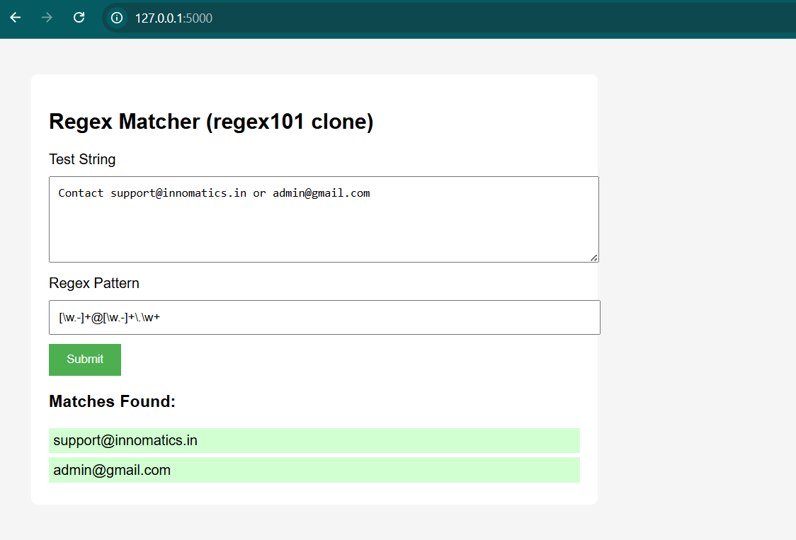

- Conclusion
This project successfully demonstrates the basic working of a regex testing tool similar to regex101.com. It helped in understanding regular expressions and the interaction between frontend and backend using Flask. The application fulfills all the requirements mentioned in the task.

